Terraform

Italic words – referrer words, referring to what’s written
Bold words – definitions

Terraform Intro
Terraform – Infra as a code
  - Provide infra setup as config file

IaC – Infrastructure as code
- To avoid manual errors, we’ve codified the provisioning infrastructure.(we can jus add AWS instances of the kind we want but sometimes it leads to manual mistakes)

Categories of IaC tools:

Confign mngt | Server templating | Provisioning tools
Ansible  Puppet  Saltstack | Docker,  Hashicorp – Packer, vagrant | Hashicorp – terraform  Cloudformation (AWS)
- To install and mng software  - Idempotent | - To make a custome image of a VM or a container  - Immutable infrastructure | - Implement the infrastructure into deployment

Declarative tools | Imperative tools
Define whats needed,  - the instances, S3 buckets, ..  - then the tool will manage how the API calls should work to get the needed items | Specifying what’s needed and the sequence to get the item  - tools like terraform falls into imperative tools
Categories of IaC:
- Adhoc scripts
- Config mngt tools
- Server templating tools
- Orchestration tools – eg: kubernetees
- Provisioning tools – to provide/feed/input the cloud config

IaC Provisioning tools
Cloud specific | Cloud agnostic(not specific to any Cloud Service Provider(CSP))
Cloud formation(AWS)  Azure resource mangaer(Azure) | Terraform  - Can be used for any API available in the internet.  - Spans across all csp  Pulumi

Patterns
- A provisioning tool, can be used with configuration management tool like Ansible
  - Terraform + ansible (config mngt)
  - Terraform + server templating
  - Terraform + Orchestration

--Udemy Course--

Terraform
- Phases:
  - Init – terraform init
    - Initializes the environment to launch the resources
  - Plan - terraform plan
    - Provides the execution plan
  - Apply (Idempotent) - terraform apply
    - Subsequent apply in terraform only brings the desired/defined component avoiding any missing resource.
  - terraform show – shows the output of a resource – the value, the resource generated.
    - terraform output – shows all the output variables defined & all files in the configuration directory
      - Main apln: pass the variable to other IaC tools
  - terraform destroy – destroys the resource

- Resource - Every object the terraform manages.
- .tfstate - blueprint of real world infrastructure
- Control of resources - Import resources created by other tools or by other service providers and takes the control of those resources.

Terraform - .tf state format
Configuration file:
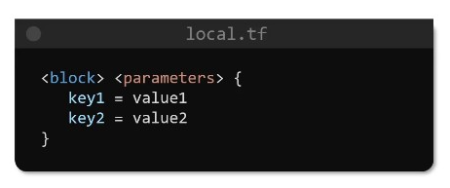
Resource type:
Before the _ :Local – provider
After the _ :File – resource
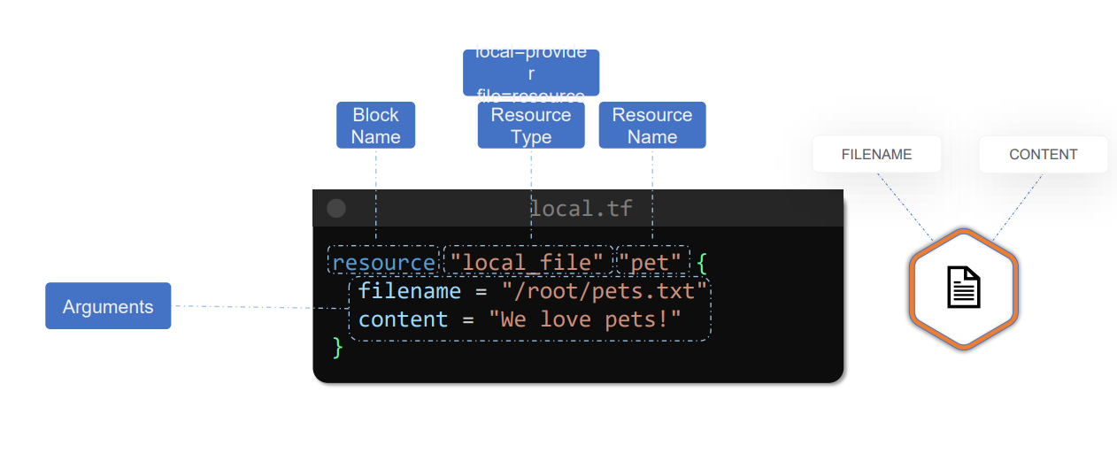
Terraform init | Creates plugins for the new providers added | Adding a provider to the main.tf file – we’ve to “init” again, as the plugin for the provider has to be created in the configuration file.
Terraform plan | Provides the detailed plan of resources to add, change, destroy
Terraform apply | Applies the specified action on resources | This returns the argument value, the main.tf is generating

Configuration files: in the directory
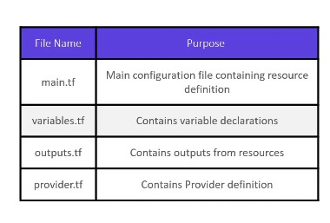

Variables
- To take inputs rather than hardcoded values

Type
Set  Default = [,] | Not have repeated values  - Like list
List  Default = [,] | Accessed with index  - var.var_name[index]
Map  Default = {} | Key = value pairs  - var.var_name[key]
List(type) | Specifying the type items in the list
Tuple([“type1”, “type2”]) | Specifying the type of each item in tuple in the perfect order.
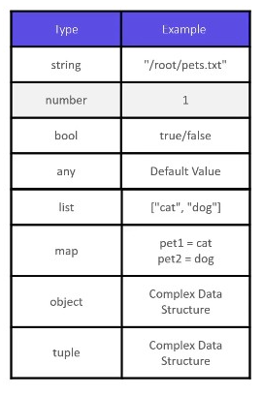

Envt variables
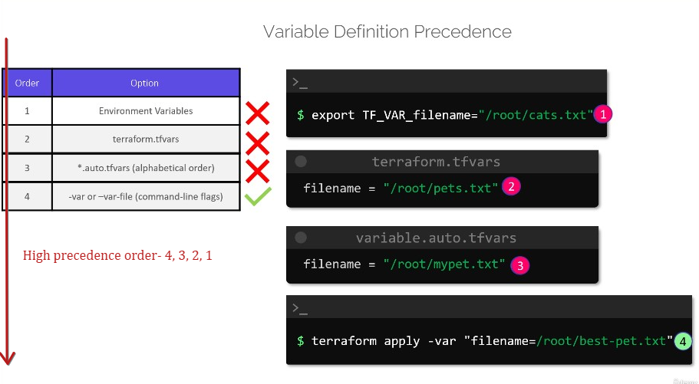
- Assigning value to variable

Explicit dependancy
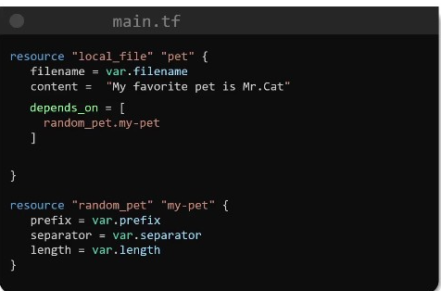
Attribute: depends_on = [resource_type . dependant_resource_file name]
- Makes sure the ‘pet’ file will be created after the ‘my-pet’ file since it depends on.

Output variables
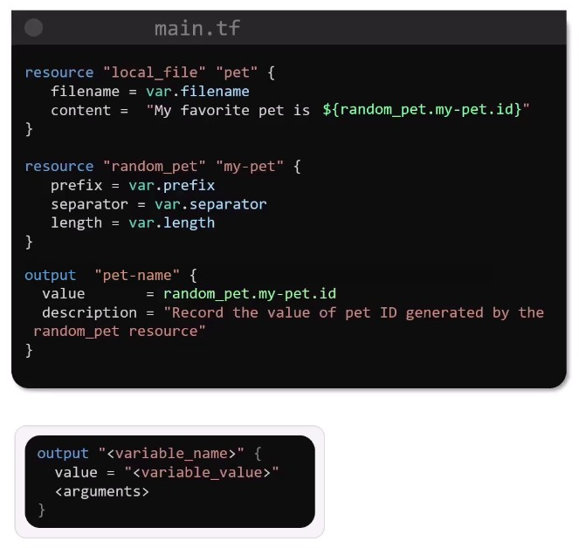
$(Interpolation) – to use the value generated by resource
Output – to retrieve the output from a resource and store it in a variable
- Mainly used to pass variable(resource output value) to another IaC tool.

To access any block value:
- resource_type.resource_name.id
    - id(resource value’s id) – with id we can extract the resource’s value.

Summary:
- Resource blocks
  - Contains the definition of resources – instances,..
- Variable - to store a value for a variable.
- Input
  - Giving input value to a variable from the live envt(otherwise we'll store it in variables and use acc.)
    - Terraform apply - var "var1 = variable_value"
- Output
  - To get the value generated by resource and store it in output variable, further can be passed to any other Iac tool.
    - Terraform output output_var/resource_name
      - -> shows the value of output_var or value generated by resource.
    - Terraform show – shows the value of all the resources.

State

Intro
Init – downloads the necessary plugins for the provider
Plan – accesses the State file and provides the changes will be done (configuration file vs state file)
Apply – refreshes the “in memory state” - ‘Apply command’ ensures the real world infrastructure is upto/as per the configuration file
  - Creates unique Id for the resource it generates
  - Creates state file – “hhh.tfstate”
  - State file:
    - Json datastructure: maps the real world infrastructure into the resource definitions
- While working on state dependant commands, it takes seconds to mins for terraform to load the resources while refreshing the state. To avoid the delay, using the flag “—refresh=false” terraform doesn’t refresh, rather access the resource data/state from the cache of resources.

Tracking Metadata
- Terraform tracks the metadata through the state file.
  - Reconciling – synchronises the state file(current state) with the configuration file(desired state).

Performance
- Reconciling the state file each time takes much time, so we’re using the cache attributes – terraform takes the real world infrastructure details from the ‘cache attributes’ rather than reconciling each time.

Collaboration
- State file – by default stored in the configuration file
  - To make it widely accessible among the team, its better to store the state files in cloud spaces – Terraform cloud, AWS S3, Google cloud storage.
Destroying:
- Destroying the resource from the configuration file - the state first destroys the dependant resource then the dependancy.

Working with Terraform

Terraform commands
terraform validate | Validate the syntax | Validate the syntax of the configuration file and suggests the error
show | Shows the resource | Shows the resource created by configuration file with all the attributes
fmt | Formatize code | Formats the content – for better readability
providers |  | Lists the providers of the configuration file
Providers mirror directory_path |  | Copies the plugins needed for the configuration file to a new directory
Validate |  | Validates the syntax and arguments of the configuration file and let us know the error(syntax and argument error).
output |  | Prints all the output variables
apply -refresh -only |  | Reconciles the state file  - It doesn’t change/update the resource file(configuration file) it just reconciles the state file if incase there’s any manual setup/update.  - Plan & apply usually refreshes the state file before creating an execution plan to ensure if its reconciled.
apply -refresh=false |  | Let terraform not refresh the state file to avoid the time consumed rather terraform accesses the state of resource from the cache of resources.
apt install graphviz-y  terraform graph | dot -Tsvg > graph.svg |  | To visualize the resource blocks and dependencies in flowchart/Graph  graphviz - tool to visualize the graph  dot – command to output the terraform graph -> graphviz tool

Mutable & Immutable infrastructure
Mutable Infrastructure – updating the existing things leads to problems
- In-place update leads to configuration drift [i.e. Mutable]
  - In-place update – upgrading/updating the resources (e.g. Nginx servers) manually on a cycle basis.
  - Configuration drift – updating 2 servers out of 3 and leaving behind the 1 server in older version(e.g. due to any dependancy related issue) leads to so many complications in running softwares
- To avoid configuration drift, we’re adding a new updated version of the resource and deleting the existing older version.[i.e. Immutable]
Immutable infrastructure – in immutable infrastructure we delete the existing resources and adds/creates the new resources with the needed modification, rather than updating the existing resources.
In general, terraform deletes the resource first and then creates the new resource.
What if we want the resource to be created first before deleting the resource ?..

Life cycle rules
Used inside the resource block
lifecycle{  create_before_destroy = true  } | - Creates the resource first before destroying
lifecycle{  prevent_destroy = true  } | - Don’t destroy the existing resource whether it creates new resource or not.
lifecycle{  ignore_changes = all  ignore_chnages = [  specific_tags(e.g. name, AMI)  ]  } | - Ignore any changes made to the attributes(all attributes/specific attributes) either changes made within terraform or outside in any other tool.

Data Source
- To read resources, provisioned outside terraform(available outside terraform control)
- The data read from data source(outside terraform) will be available under data object
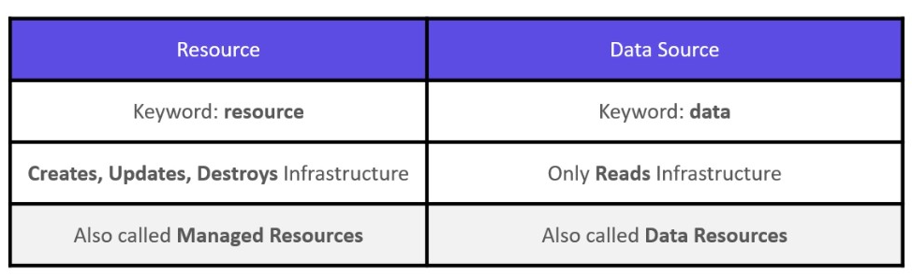

Meta Arguments
Use inside the resource block
depends_on | 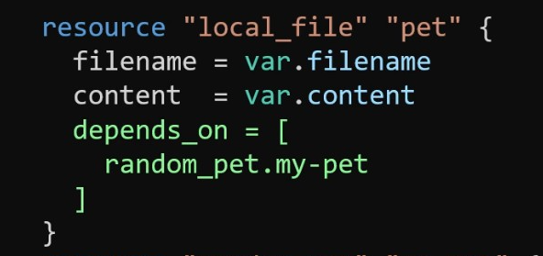
lifecycle | 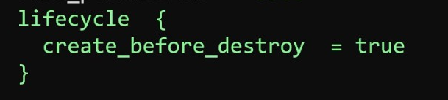
count | Create many same instances of the resource by specifying the count

- The resources in the list are stored on array index. Deleting the A[0] leads the positioning of subsequent resources to move upward: A[1]A[2] -> A[0]A[1] – it will collapse the intended resources to be deleted.
for_each | Doesn’t work on list  Output type: Map  - Use map or set 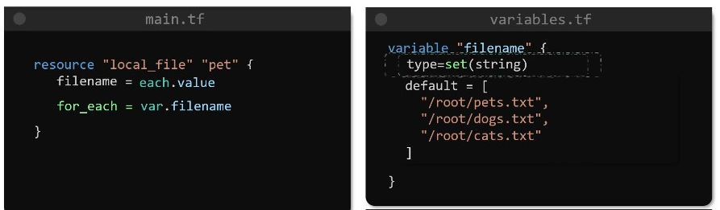  - Use toset() // to convert from list to adaptable data type 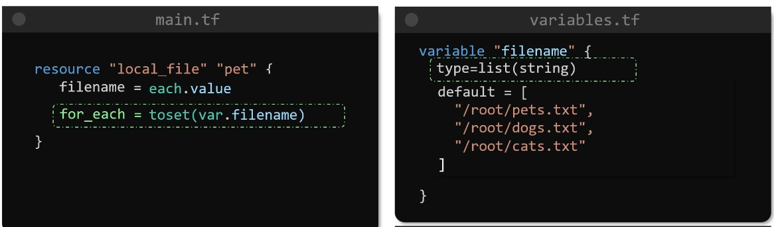

Accessing AWS Resources
aws iam help
- List all the commands iam has, what we can do with iam.

aws iam help | grep – i attach
- Shows all the commands associated with attach
- grep – to look for a specific command with keyword.

AWS CLI
aws [options] <command> <subcommand> [parameters]
aws --endpoint http://aws:4566 create-user –user-name Lucy

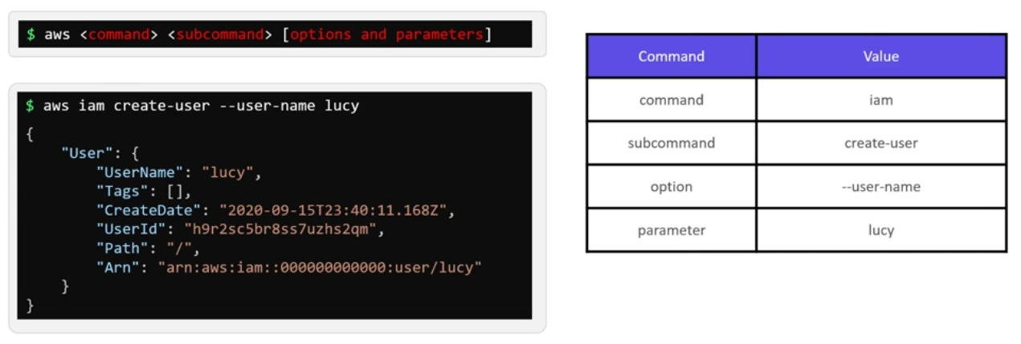

Accessing Resource through Terraform
provider “provider_name”{
- region, access key id, secret access key,..
//All these details to connect to the user acessibilities in the provider.
//Specifying the access key id & secret access key we can avail the accessible resources of the specific user
}

resource “resource_type” “resource_name”{
- resource block details
}
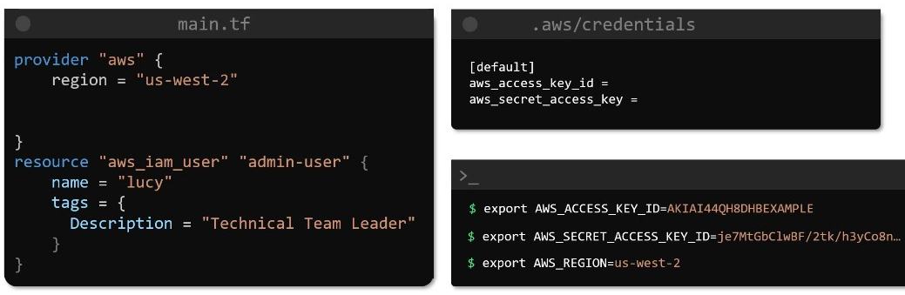

Ex:1 – To create set of users
- Declaring all the users in the variable file 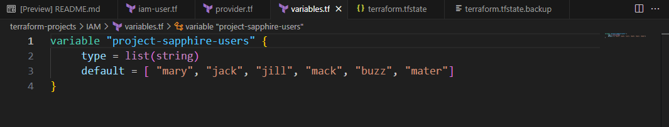
- Accessing the variables from the variable file through for_each. 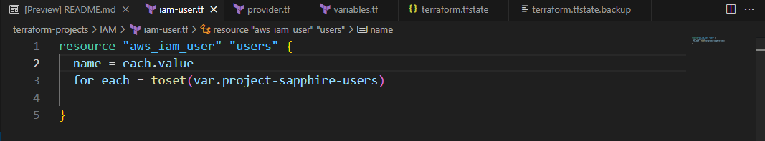

AWS Resources

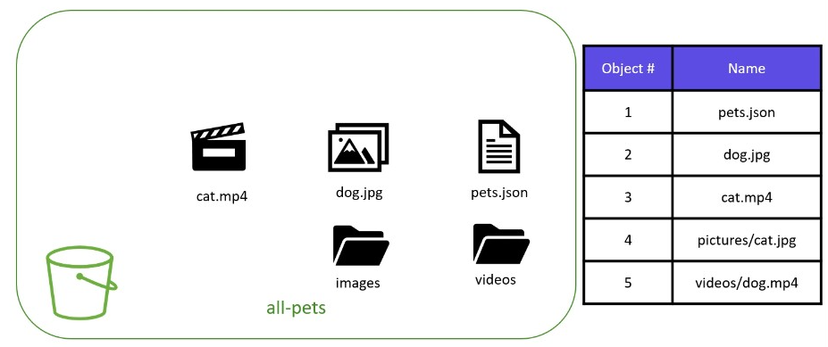
AWS S3
- Infinitely scalable – stores objects inside containers
  - Each resource/file in the S3 is stored as object with a key

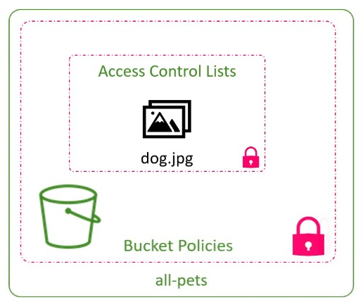
- Access provided in
  - bucket level – bucket policies
  - resource level – access control lists

Exercise:
Resource: accessed through resource id
Creating a bucket named: finance-21092020
Creating an object with the bucket value specified - object will be created inside the bucket
Data: accessed through unique identifier (ARN for aws)
Importing IAM group from external resource
Assigning the policies
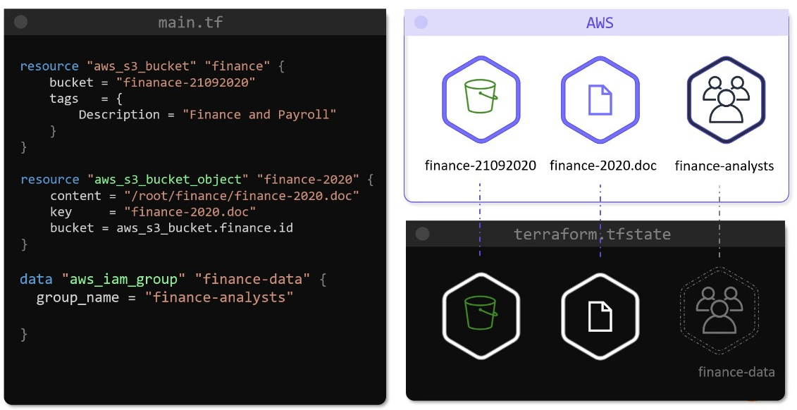
- aws_s3_bucket.finance.id

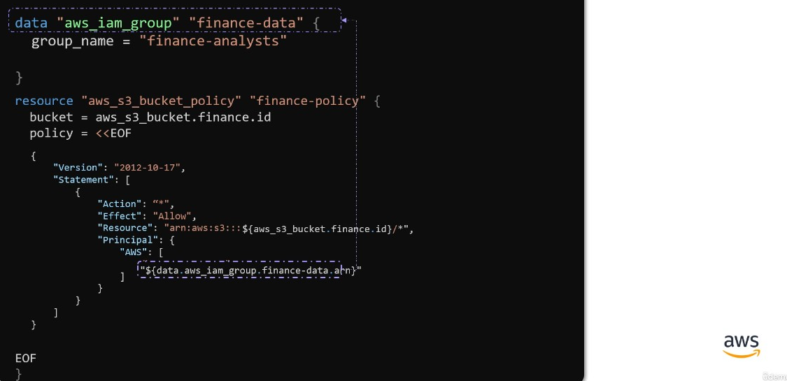

DynamoDB
- Highly scalable, low latency, fully managed by AWS
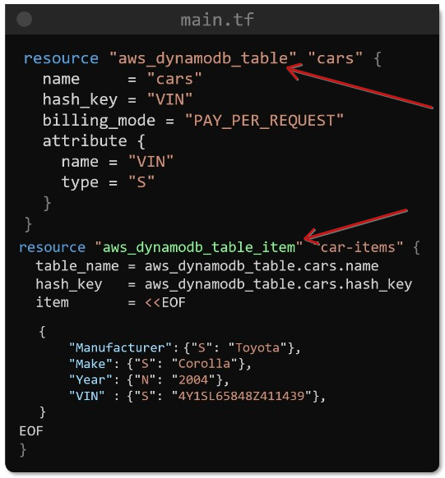

Creating table with the primary key

Adding item to the table

State Management system
- Terraform state files are stored in S3, for
  - Atomic State locking
  - Automatic reconcilation
  - Sensitive data handling
  - Collaboration – all users code points to the same state file.
    - No separate state files and versioning like in Git
- All other code files are stored normally in Git
- State locking in .tfstate file can be enabled through DynamoDB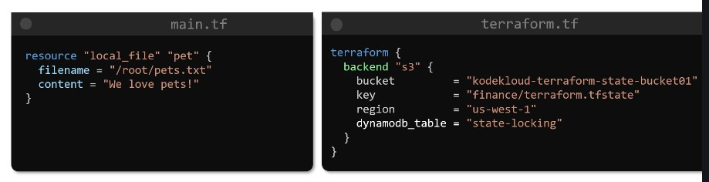

State commands
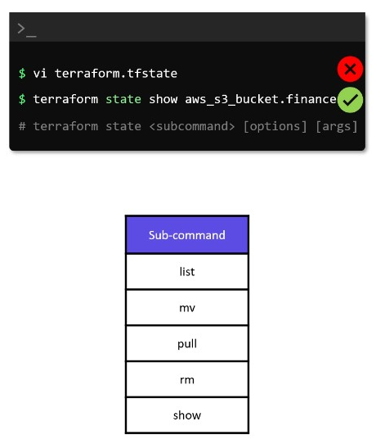
pull – clones the state file in local space
---
list – lists all the resources
show – shows full details of a resourcem
mv – renames the existing resource
rm – removes the specified resource from terraform management

Provisioner<
- To run commands/scripts inside resource block, for post creation tasks(minor works in already created setup/infra)

Terraform Taint
Taint – marking a resource as tainted, so in the subsequent apply, terraform will destroy and recreate the specified resource.

Terraform Import
- To import a resource which’s available outside of terraform’s management scope. 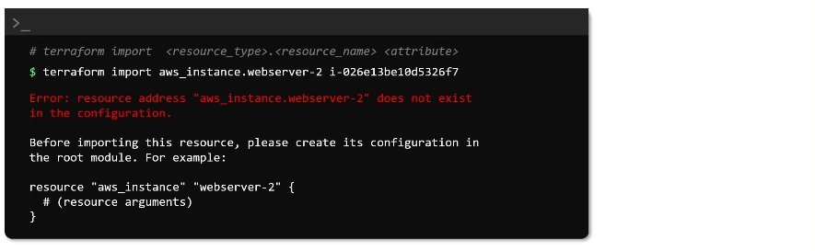
- After importing a resource in terraform, the resource will be updated in the state file
  - But in the configuration file we need to update the resource details by ourself, checking the CSP console or from available data about the resources.

Modules
- A configuration directory with a set of configuration(.tf) files.
- Child Modules(All the modules) will be declared in the root module
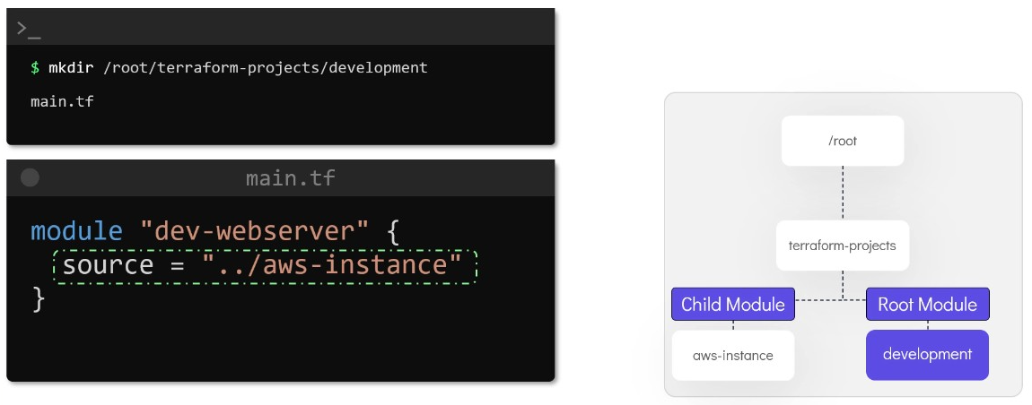
- Server with DynamoDB has been created in a module – that module can be imported in other modules 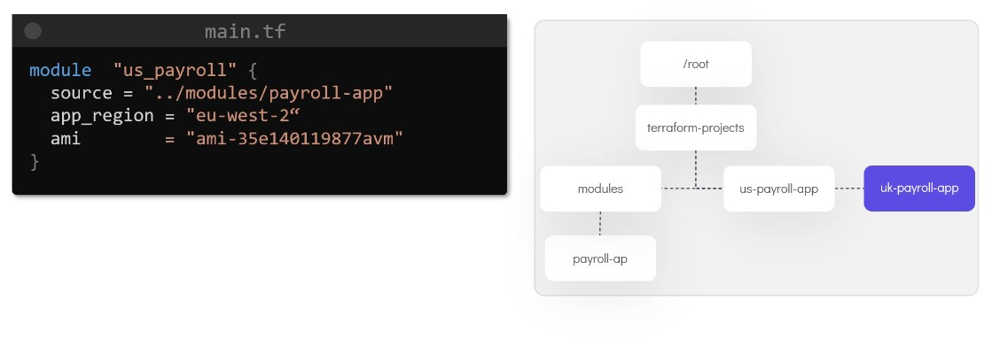

Orion Platform – POC

Terraform starter
Terraform plan
- Refreshes statefile – Reads state file and quries aws resources and then refreshes state file,
- Compares tf code vs statefile – refreshed state file Vs terraform code to make a plan.
Terraform apply
- Updates resource based on tf code, updates statefile
Terraform apply tfplan: Applies the planned resource
Terraform plan apply, the apply command again does the plan from beginning. To avoid this we can freeze the plan developed by terraform plan:
terraform plan -out=tfplan
terraform apply tfplan

Terraform State mngt:
Terraform Code == Desired State
Terraform State == Current Known State
AWS == Real State

Terraform Commands
terraform init | Downloads the necessary plugins for the resources
terraform validate | Validates the code
terraform plan | calculates the difference between terraform code and aws infrastructure, and shows the plan.
terraform plan -var-file=*.tfvars -out=tfplan | Uses the .tfvars file to upload the values in variable.tf and stores the plan in tfplan.
terraform plan tfplan | Uses the plan made in tfplan
terraform apply
terraform destroy
Resource targetting | Applicable for plan, apply, destroy  a specific resource / specifc module / specific resource inside a specific module  Eg:  terraform plan -target=aws_instance.web, terraform apply -target=aws_instance.web  terraform plan -target=module.vpc  terraform plan -target=module.ec2.aws_instance.main  terraform apply -target='aws_instance.ec2["mgmt_utility_dev"]
State resource management  terraform state list  terraform state show 'module.ec2["mgmt_utility_dev"].aws_instance.main'  terraform state rm 'module.ec2["mgmt_utility_dev"].aws_instance.main' | Lists all the resources managed in tf state  Provides description of the resource available in state  Removes the resource from state so that another aws resource can be imported to this resource tf configuration.

Terraform arch
Layers in terraform arch
Provider lyr  Provider.tf | Envt layer  (variables)  Dev.tfvars | Main lyr  main.tf, vars, o/p | Modular layer  Individual resources – main, vars, o/p | Backend lyr  Backend.tf
Provides terraform, cloud provider: aws/azure | Passing envt(dev/qa/prod) specific configuration values to main lyr | Passes the value to resources in the modular layer | Receives the value and uses that value in resource | Helps in storing the state file
provider block  terraform block | Variables | Module block | Resource block  Data block  Variable  Output  local | Backend block
Managing multiple versions of a same resource
 | Passes values in map(object) format | Variables.tf – receives multiple copies of a resource  == in map(object) format  Main.tf – uses for_each on the variable | Contains standard definition for the resource

Terraform execution flow: load files(all the tf files will be loaded and created as a single configuration) resolve values build graph from main.tf execute
Loads all the .tf & .tfvars files simultaneously
- Variable resolution
- Graph building – tf analyzes main.tf to figure out the dependencies and executes the resources in the dependency order
- Terraform parallely
  - Resolves variables to it’s values
  - Starts at main.tf file
    - Passing .tfvars to .tf file:
      - terraform apply -var-file="environments/dev.tfvars"

Resource Acquisition
Read aws resources thoroughly with AWS CLI scripts to generate data of the resources in json fmt
Create respective tf moduless
Resource block – creates and manages the resource
Terraform import – to take over existing resource
    - terraform import resource_provider.resource_block_name arn
      - terraform import aws_instance.app i-0123456789abcdef0
    - terraform import + terraform plan = helps in match up to the level of existing infrastructure
Data block – uses the existing resource by it’s reference

Knowledge on resources
VPC, Subnet, NACL, Security group, Route table
Resources need to be taken under terraform:
EC2, S3, Container registry, EBS, AWS Glue, Kafka, Secrets manager, KMS, Snapshot, AGW/ALB
EKS

S3

EC2
: key-value pair for an ec2 server == lock(public key)&key(pvt key) for a server
- create sshkey locally public key(id_rsa.pub), pvt key(id_rsa)
  - public key – used into terraform while creating the server
  - pvt key – stored personally to ssh into the server

Setting up EC2 resource in terraform:

Issues faced
- don’t have permision to attach iam role to a server
  - iam user should be given access to attach specific iam roles to aws services
  - eg: iam user should contain the iam policy:
    - {
    - "Effect": "Allow",
    - "Action": "iam:PassRole",
    - "Resource": "arn:aws:iam::123456789012:role/OrionEC2Role"
    - }
- ami's snapshot is encrypted, so can’t able to create ec2 server without providing snapshot’s enc key.
  - Creating new ami for the same ec2 server- without snapshot encryption(since the volume isn’t encrypted)

tools designed for IaC usually enforce a particular structure for your code, whereas with a general-purpose programming language,
a common pattern is to use Packer to create an AMI that has the Docker Engine installed, deploy that AMI on a cluster of servers in your AWS account, and then deploy individual Docker containers across that cluster to run your applications.

